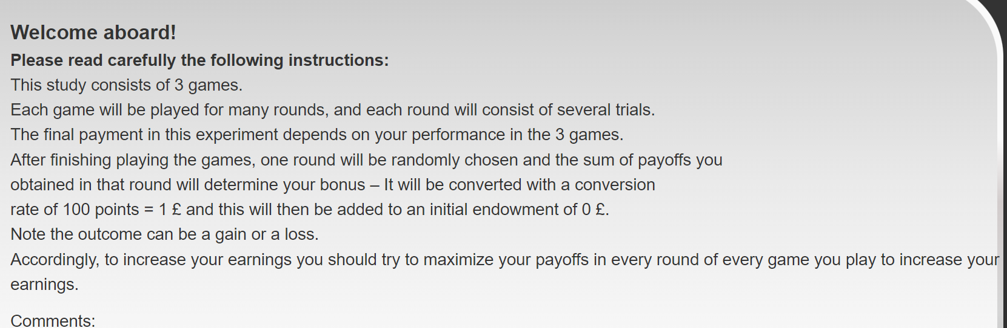

1. “welcome aboard! This study consists G games; each game will be played for many rounds which will consist of several trials. The final payment in this experiment depends on your performance in the games. After finishing playing the games, a single round from each game will be randomly chosen and the sum of payoffs you obtained in those randomly selected rounds will be converted with a conversion ratio of ExchangeRatio points earned equals 1 CoinSign. Note the outcome can be a gain or a loss. Accordingly, you should try to maximize your payoffs in every round in every game you play to increase your earnings.“

G=3

ExchangeRatio=100

CoinSign= £

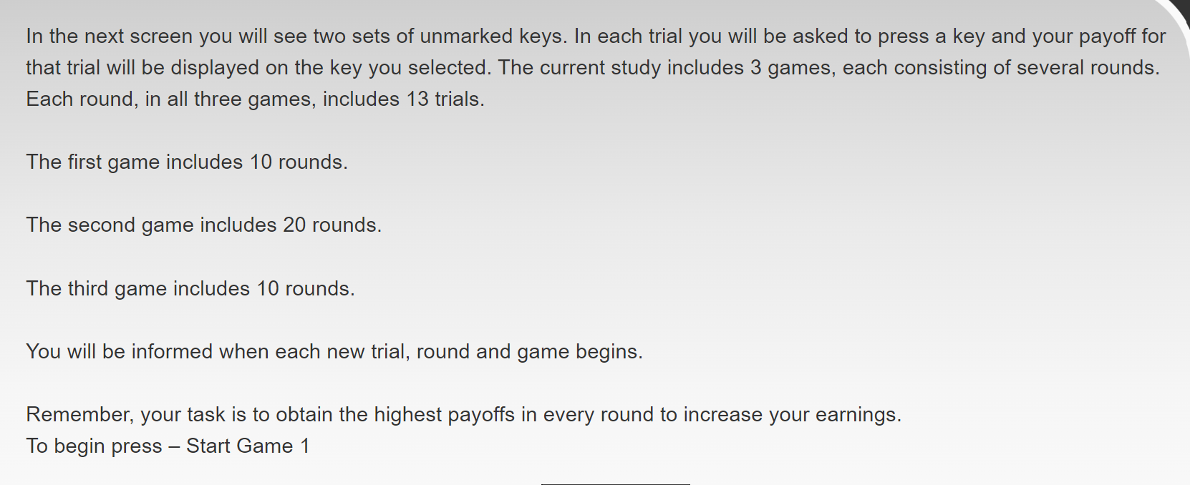

1. ““In the next screen you will see two sets of unmarked keys. In each trial you will be asked to press a key and your payoff for that trial will be displayed on the key you selected. Each round of will consist of T trials and you will be informed when a new round begins and when the keys are changed. You will play this game for a total of R rounds.

You will play G games like this. Each game has a unique payoff structure and you will be informed when the current game is finished and a new game is about to begin. Remember – your task is to obtain the higher amount of payoffs in every round to increase your earnings. Press –Start First Game – to begin.”

T=13

R=15

G=3

Main_Game:

You are on trial t out of T trials in this round

Round r out of R rounds

Game g out of G rounds

g, r, and t are variables that changes through the task (in contrast to G, R, T, which are determined only once before the experiment).

מזכירה להעלות לי את ההנחיות של כנרת